
Sri Lanka Institute of Information Technology

Year 2 Semester 1
Lab Sheet 08

<IT24101654>
<HASARINDA W.D.Y.L.>

Probability and Statistics - IT2120
B.Sc. (Hons) in Information Technology
Lab Sheet 08
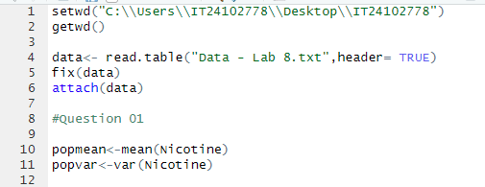
1.

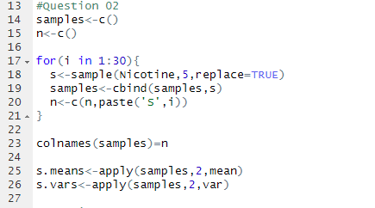
2.

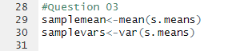
3.

4.
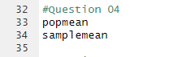
5.
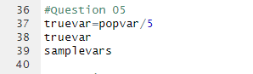
Exercise
1.
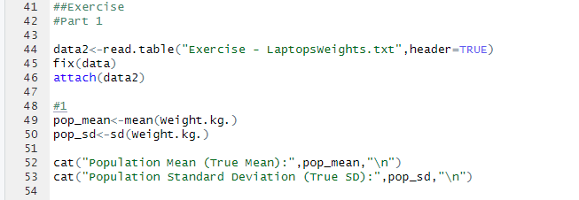
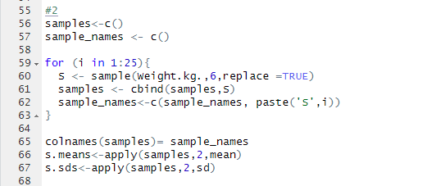
2.

3.
